1. Simulate 30 rolls with =RANDBETWEEN(1,6). What is the probability of rolling a 3 exactly 5 times? (Hint: Use BINOM.DIST)
Solution:
This problem is based on the Binomial Distribution because:
- There are a fixed number of rolls (30).
- Each roll is independent.
- Each roll has only two outcomes — “Success” (getting a 3) or “Failure” (not getting a 3).
- The probability of success stays constant at $p=\frac{1}{6}$.
Formula:
$P(X=k)=(\frac{n}{k})p^{k}(1-p)^{n-k}$
Given:
- $n=30$
- $k=5$
- $p=\frac{1}{6}$
Step-by-step:
$P(X=5)=(\frac{30}{5}){(\frac{1}{6})}^{5}{(\frac{5}{6})}^{25}$
In Excel:
=BINOM.DIST(5, 30, 1/6, FALSE)
Final Answer:
$P(X=5)=0.1921 or 19.21\%$
So, the probability of rolling a 3 exactly 5 times in 30 rolls is 19.21%.

2. Generate 100 values in Excel using the continuous uniform distribution RAND() and plot a histogram. Describe the shape of the distribution.
Solution:
The RAND() function in Excel generates numbers between 0 and 1, where each value in this range is equally likely.
This follows a Continuous Uniform Distribution.
In Excel:=RAND().
Explanation:
A uniform distribution means all values occur with equal probability.
So, when you plot the histogram, it should look flat — meaning no particular number range appears more often than another.
Final Answer:
The histogram is roughly flat or rectangular, showing that all values between 0 and 1 occur with almost equal frequency.

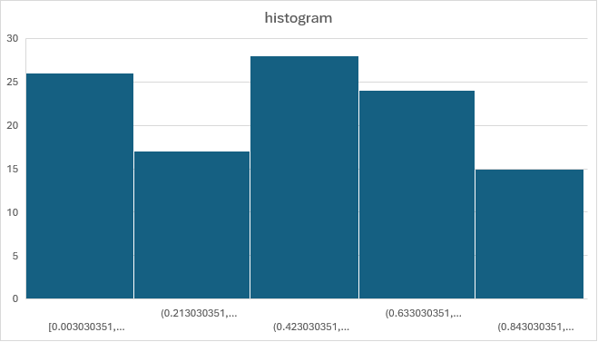
3. A dataset has a mean of 50 and a standard deviation of 5. What percentage of values lie between 45 and 55 if the data follows a normal distribution?
Solution:
This question uses the Empirical Rule (68–95–99.7 Rule) for Normal Distribution.
Empirical Rule:
- 68% of data lies within ±1 standard deviation.
- 95% lies within ±2 standard deviations.
- 99.7% lies within ±3 standard deviations.
Given:
- Mean (μ) = 50
- Standard deviation (σ) = 5
Range:
45 = 50 - 5 = μ - 1σ
55 = 50 + 5 = μ + 1σ
So, the range from 45 to 55 covers one standard deviation from the mean.
Final Answer:
Approximately 68% of the values lie between 45 and 55.

4. What is the concept of standardization (z-score), and why is it important in data analysis? Explain the formula and how standardization transforms a dataset.
Solution:
Concept:
Standardization (or z-score) converts raw data into a common scale that shows how far each value is from the mean, measured in standard deviations.
Formula:
$z=\frac{x-μ}{σ}$
Where:
$z$= standardized value
$x$= raw score
$μ$= mean
$σ$= standard deviation
Why It’s Important:
- It allows comparison of values from different datasets or scales.
- It helps identify outliers (values far from the mean).
- It’s essential for many statistical and machine learning methods.
Transformation Effect:
After standardizing:
- The new mean becomes 0.
- The new standard deviation becomes 1.
Final Answer:
Standardization transforms data into z-scores, making them comparable and centered around zero.

5. What is Kurtosis and its types?
Solution:
Concept:
Kurtosis measures how heavy or light the tails of a distribution are compared to a normal distribution — in simple terms, it shows how peaked or flat a distribution is.
Types of Kurtosis:
- Mesokurtic (K = 3)
  - Same as a normal curve.
  - Moderate tails and peak.
- Leptokurtic (K > 3)
  - Sharper peak and heavier tails.
  - Indicates more outliers.
- Platykurtic (K < 3)
  - Flatter peak and lighter tails.
  - Indicates fewer outliers.
Final Answer:
Kurtosis describes the "tailedness" of a distribution.
Types are Mesokurtic, Leptokurtic, and Platykurtic.

6. Explain why the uniform distribution is a good model for the outcome of rolling a fair die.
Solution:
A uniform distribution means every possible result has an equal chance of happening.
For a fair die:
- Outcomes: 1, 2, 3, 4, 5, 6
- Each outcome has the same probability:
$P(X=i)=\frac{1}{6}, i=1,2,...,6$
Since all outcomes are equally likely, this matches the definition of a discrete uniform distribution.
Final Answer:
A fair die follows a discrete uniform distribution because each of its six faces has an equal probability of appearing.

7. Use Excel to compute the probability of getting at least 8 successes in 15 trials with success probability 0.5.
Solution:
We are finding:
$P(X≥8)=1-P(X≤7)$
where $X∼Binomial(n=15,p=0.5)$.
In Excel:
=1 - BINOM.DIST(7, 15, 0.5, TRUE)
Explanation:
The cumulative probability up to 7 gives $P(X≤7)$.
Subtracting this from 1 gives the probability of getting 8 or more successes.
Final Answer:
$P(X≥8)=0.5$
This makes sense because with $p=0.5$, the distribution is symmetrical — half the time you’ll get 7 or fewer successes, and half the time 8 or more.

8. How does log transformation help in stabilizing variance and making data more normally distributed?
Solution:
A log transformation is used when data is highly skewed (especially right-skewed).
1. Stabilizing Variance:
Large values get compressed more than small ones.
For example:
$log⁡(100)=2,log⁡(1000)=3,log⁡(1,000,000)=6$
This compression reduces the spread of data, making variance more stable.
2. Making Data Normal:
Right-skewed data has a long tail on the higher side.
Taking logs “pulls in” the tail, making the data more symmetric and closer to a bell-shaped curve.
Final Answer:
Log transformation:
- Stabilizes variance by compressing large values.
- Makes data more normally distributed by reducing right-skewness.

